**Project Design Phase-II**

**Technology Stack (Architecture & Stack)**

|  |  |
| --- | --- |
| Date | 03 October 2022 |
| Team ID | PNT2022TMID16946 |
| Project Name | Project –IoT Based Safety Gadget for Child Safety Monitoring and Notification |
| Maximum Marks | 4 Marks |

**Technical Architecture:**

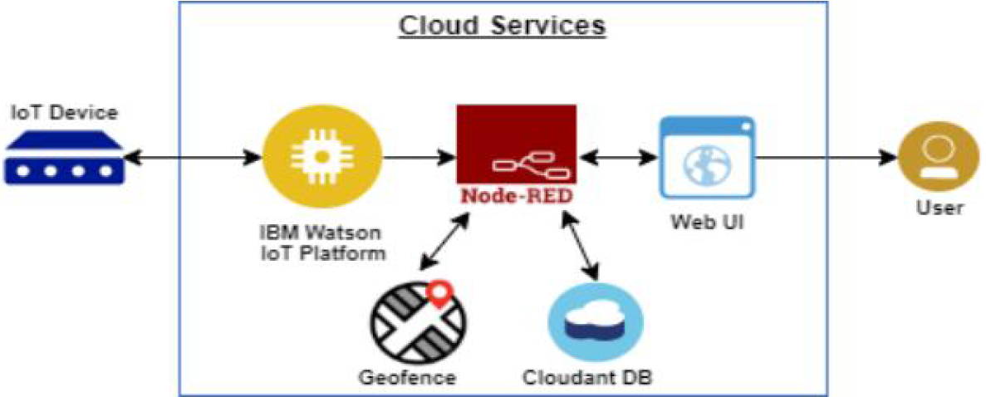

**Table-1 : Components & Technologies:**

|  |  |  |  |
| --- | --- | --- | --- |
| **S.No** | **Component** | **Description** | **Technology** |
|  | User Interface | Users had to register and outlook the other  device’s location e.g.Web UI, Mobile App,  etc. | HTML, CSS, JavaScript / Angular Js /  React Js etc. |
|  | Application Logic-1 | Registration of child’s and parent’s device in each  other device. | Python,Embedded C. |
|  | Application Logic-2 | The child’s GPS should be in ON condition,  Parent’s device should always be correlated to  Child’s appliance. | IBM Watson STT service  IBM Watson Assistant |
|  | Application Logic-3 | The information is to be collected and dispatched  to the authenticator via GSM equipping the GPS  coordinates to efficiently locate access and monitor  the Child. | IBM Watson Assistant  IBM Watson STT service |
|  | Database | Data Type can be any configuration such as  arbitrary binary data, or text. Location history is  stored in the cloud and the values include distance,  latitude, and longitude. A user-defined blob of data  transmitter from Cloud IOT Core to a device etc. | MySQL, NoSQL,SQLite, InFluxDB, etc. |
|  | Cloud Database | Users install tracking software on a cloud  infrastructure to perpetrate the database. | IBM DB2, IBM Cloudant etc. |
|  | File Storage | Files will be labelled with what they encompass  and how long they should be kept. | IBM Block Storage or Other Storage Service or Local Filesystem |
|  | External API-1 | The purpose of the external API employed in the  device is to exploit the internet for communicating  and executing allotted operations efficiently. | IBM Weather API, etc. |
|  | External API-2 | External API laboured in the device to unveil the  data that permits those gadgets to disseminate  data to your device/mobile, functioning as a data  interface. | Aadhar API,City Geo-Location Lookup  API, etc. |
|  | Machine Learning Model | IoT and machine learning deliver insights otherwise  hidden in data for prompt, automated retorts and  enhanced Governing. | Object Recognition Model,Danger  Prediction Model, etc. |
|  | Infrastructure (Server / Cloud) | Application Deployment on Local System / Cloud  Local Server chassis: Wearable high-tech mechanism. Cloud Server Configuration: a  tremendous network that reinforces IoT devices  and applications. | Local, Cloud Foundry,  Kubernetes ,Underlying Infrastructure ,etc. |

**Table-2: Application Characteristics:**

| **S.No** | **Characteristics** | **Description** | **Technology** |
| --- | --- | --- | --- |
|  | Open-Source Frameworks | The framework is exemplified for child safety  utilizing a Sensor network and IoT. The Key  attribute of the system is the deployment of a  smart detector for the collection of Data, cloudbased  analysis, and decision-based on Monitoring  for children's Safety. The framed  solution is in the form of an android application  furnishing the end user leisure surveillance of their  children. | Mainflux, Thinger.io, and Zetta  for non-stop streaming of child  condition Open remote |
|  | Security Implementations | To activate the alarm and facilitate video recording  whenever the emergency button is pressed. We  can use the cloud to accumulate the surveillance  data of the children. The wifi modules are of  assistance in sending the monitoring particulars,  the user will be notified with an update if any errors  are found, for the efficient functioning of the  device. | e.g. SHA-256, Encryptions,regarding  child condition, Firewalls, Antivirus, and  Data Loss Prevention,etc. |
|  | Scalable Architecture | This methodology can be further enhanced by the  installation of the mini camera inside a smart  gadget for exemplary security and protection so  that a glimpse can be caught on the live footage  on the parental phone during panic circumstances.  If an intricacy arises parents can see some of the  attributes like the location, temperature, and  heartbeat of the child along with living perspective  around the children without deterrence. | Multiple Data Storage Technologies,  Reliable Microservices, Automated  Bootstrapping |
|  | Availability | The device is used to keep tabs on your child even  in a horde. It also provides the current locationalong with travel details. This system is advanced using a board programmed in embedded C and python. It is a site that is available online. | Temperature, Pulse sensor, GPS,  GSM, Web camera, Raspberry pi microprocessor |
|  | Performance | The web Page’s load time should be no more  than one second for the user's elevated  performance concerning simple aidance and  security. The originality of the system is that it  spontaneously alerts the parents/caretaker by  sending an SMS when instant attention is  indispensable for the child during a crisis. The  complete data of the children’s location will be  stocked in the repository and the execution of the  device diminishes in a less network Area. | GSM tracker, High Durable Device  Battery |